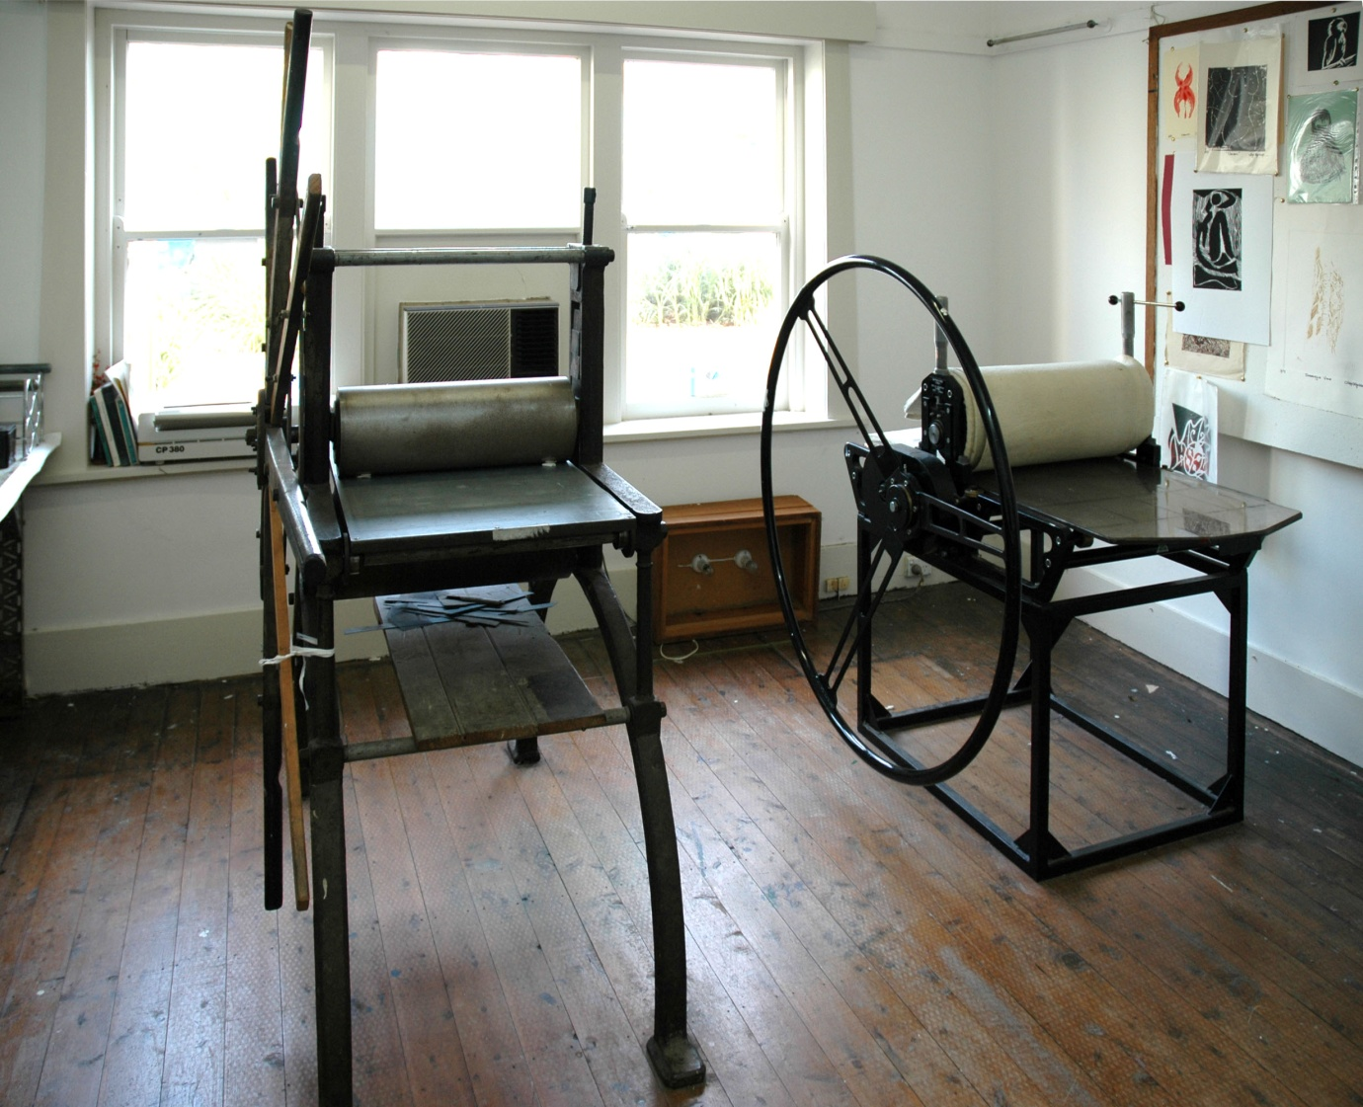

ARTIST RESIDENCIES @ GALLERY LANE COVE
Gallery Lane Cove is seeking expressions of interest from emerging and established artists for their upcoming Residency Program.
Residency includes:
- Between 3 and 6 month studio space (10m2- 3.6m x 2.9m) located in Lane Cove
- 24 hour access to studio in close proximity to public transport and shops
- Print studio access with printing presses
- 3 week exhibition at Gallery Lane Cove upon completion of residency
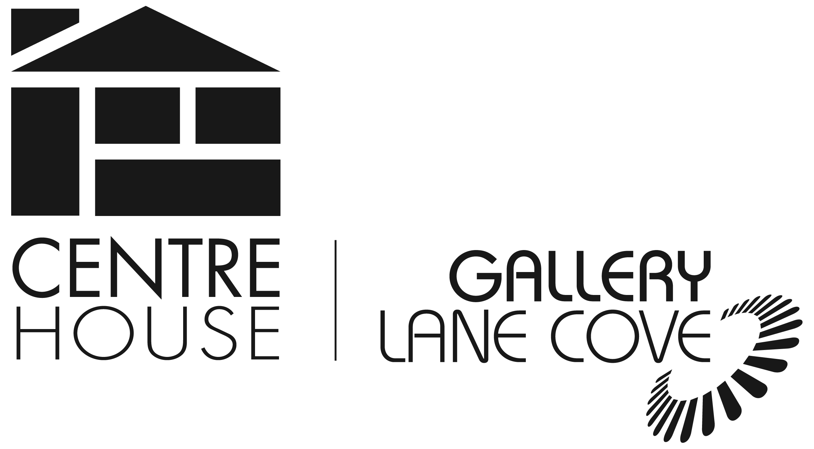
- $75 per week includes studio rent (personal studio space, print studio access, kitchen access, electricity, water) and exhibition administrative and gallery costs (500 exhibition invitations, professional gallery space with hanging system, invigilation and sales management provided)

For further information or to apply email: info@gallerylanecove.com.au

RESIDENCY APPLICATION FORM 2014

Section 1: Applicant details
Name:
Email:
Phone:
Postal address:
Website:
Proposed Residency Dates

Please tick which time period you would like for your residency
Time period: 1 month - 2 months - 3 months -

Section 2: Your proposal
Give a brief description of your practice (100 words)
Give a brief description of what you hope to achieve whilst in residence at Gallery Lane Cove (100 words)
Section 3: Support material
Please include with your application the following support material
- Up to 10 images of past work with image list
- 1 page CV

Send applications and supporting material to info@gallerylanecove.com.au

Terms and Conditions
1. Successful applicants will carry out their residency during the agreed period of time and will vacate the space by the end date stipulated by the Centre & Gallery Manager.

2. The applicant will work in a safe manner in the studio and print workshop following OH&S guidelines.

3. The applicant will provide a certificate of public liability insurance covering their residency and exhibition dates.

4. The applicant agrees to pay a rental fee of $75 per week on a schedule agreed by the Centre & Gallery manager and the artist.

5. The applicant will receive 24 hr access to a private work studio and access to the print room outside the art centre scheduled class/workshop times.

6. The applicant will receive a solo exhibition in the 1/3 gallery space in the 2015 exhibition program hire free as part of the residency program. Earlier exhibition period may be negotiable upon availability.

7. The applicant will agree to the Gallery Lane Cove’s exhibition guidelines, terms & conditions.

8. A bond of $300 is payable before commencement of residency period. This will be refunded to the applicant upon return of keys and inspection of premises.

9. The applicant agrees to carry out a workshop for the public relating to the artworks being created during their residency period.

10. The applicant will be responsible for leaving the art centre secure when leaving the premises. All doors, windows must be locked and secure before leaving at all times.

11. The exhibition must include some work created during the residency.

12. The opening drinks of the exhibition will be paid for by the artist.

I........................................................ of address .................................................................................. and

phone................................................ agree to the above conditions and submit my residency application.

Signed..............................................Dated.......................................

